Rohan Bagade, Macro Analyst
Vedda Nune, Macro Analyst
Maggie Xu, Macro Analyst

Japan Outlook
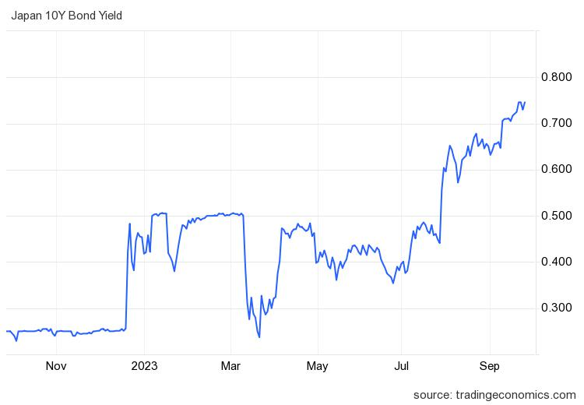
All eyes were on the Bank of Japan (BOJ) earlier this year after Japan allowed the 10-year yield to rise above 0.5% in late July. The 10-year government bond yield has now climbed to 0.76% (9/26), marking its peak since 2013. Japan’s loose monetary policy in the face of rising inflation has also led to a decline in their currency. Recent government data has shown evidence of post-pandemic recovery after Japan’s GDP surpassed expectations and grew by a remarkable 6% in the Q2 2023. The growth in the last quarter was primarily attributed to a surge in exports and tourism after the removal of travel restrictions. Conversely, underlying data indicates that Japan’s economic stability may be threatened by a drop in household and corporate spending, as Japan’s household spending has slipped 5% YoY amidst rising prices. BOJ Policymaker, Hajime Takata, emphasized the importance of maintaining ultra loose monetary policy even with the concerns about the BOJ’s ability to meet its 2% inflation target.
In the Bank of Japan’s latest update, they maintained their policy of negative short-term interest rates expressing a need for more time to assess the level of rising prices. In particular, Japan will be focusing on wages and service prices, ideally with wages continuing to rise while service prices decline. The market started to anticipate a change in course for the ultra-loose Bank of Japan, but Ueda reaffirmed the QE policy and put these speculations to rest. As a result, the Japanese Yen fell sharply against the dollar, as USD/JPY hit 149, just below the highs made in October 2022. This time last year coincided with a bottom in long-duration U.S Treasuries and U.S equities, with USD/JPY trading down from 152 to 127 over the next few months. However, last October, positioning on JPY was extremely bearish which allowed the BOJ to effectively implement their first currency intervention selling dollars for yen since 1998. This time around, positioning on USD/JPY isn’t nearly as bearish with investors having the last intervention in recent memory. For this reason, it is unlikely that a currency intervention would cause a similar selloff in USD/JPY that we saw in October 2022. Also, if their intervention were to fail that would be extremely weak for their currency as investors lose confidence in Japan’s control on the situation. The 10yr yield differential between U.S Treasuries and JGB’s has dropped from 4.3% to 3.8% over the last year, which has prevented USD/JPY from making new highs. That being said, the inflation outlook has changed drastically with the recent acceleration in inflation. Over the last year, CPI has risen from 3.7% to 5.9%.
According to Deloitte's July 2023 economic outlook for Japan, the yen has weakened against the dollar, contributing to the country's economic challenges. A weaker yen can affect Japan's trade balance, making exports more competitive but also increasing the cost of imports, including energy and food. This weakening yen is one of the key factors alongside high inflation and rising unemployment that may compel Japan to tighten its monetary policy. High inflation is another pressing issue in Japan, which can be exacerbated by the weaker currency. Rising import costs due to a depreciating yen can contribute to inflationary pressures in the economy, impacting consumers' purchasing power and overall economic stability. Moreover, the combination of a weak yen and high inflation can strain businesses and contribute to rising unemployment. As costs rise, companies may struggle to maintain profitability, potentially leading to job cuts and increased unemployment rates. Addressing these issues will require careful policy considerations and potentially monetary tightening to restore stability to the country's economy, including adjustments to interest rates and other monetary tools.
China Outlook

For years, China's economic growth relied on investments in factories, skyscrapers, and infrastructure. This model enabled China to become a global powerhouse, however, it is now no longer effective. Currently there are several regions in China with underutilized infrastructure like bridges and airports, along with a surplus of vacant apartments. This has caused a sharp decline on investment returns. With a decline in private investments and exports, officials claim they have limited alternatives but to continue borrowing and pursuing infrastructure projects to stimulate their economy. Economists claim that this will cause China to move in a phase of significantly reduced growth, exacerbated by unfavorable demographics and an expanding rift with the U.S. and its allies, which poses risks to foreign investment and trade. This might not simply signify a temporary economic downturn but rather the beginning of an extended period of decline. While China's GDP growth is anticipated to be less than 4% in the coming years, with expectations of it dropping to 2% by 2030,
it's important to note that past economic forecasts have often proven to be inaccurate. The shrinking labor force and slowing productivity growth pose additional challenges to China's economic prospects.China's response to these challenges involves continued borrowing and infrastructure development, particularly at the local level. As you can see on the left graph, the huge drawdown in funds accessible to developers seen in 2022 has caused massive problems for China’s real estate market, and their economy as a whole. A wave of defaults and bankruptcies are taking place in China with their second largest developer, Evergrande, announcing they missed principal and interest payments of $550M while being unable to issue debt in any capacity. As you can see on the right graph, Goldman’s Sachs Prime Brokerage Group reported record bearish flows from hedge funds in Chinese equities, indicating extreme pessimism from Wall Street.

